Upstream Atlas – Version 2 Website

Top Bar Navigation
Remove the Search Icon
“Home” – takes the user to the top of the Homepage
“Countries” – scrolls down to the “Coverage Across West Africa” section
“Chapters” – scrolls down to the "Browse by Topic" section
Remove “Resources”
Remove “About”
Add “Search” – scrolls down to the "Search Upstream Atlas " section
Add “Contact” – opens up the users default email client and prepopulates the To field with matt@operatorassetexchange.com and Subject with “Upstream Atlas Enquiry”

Hero section
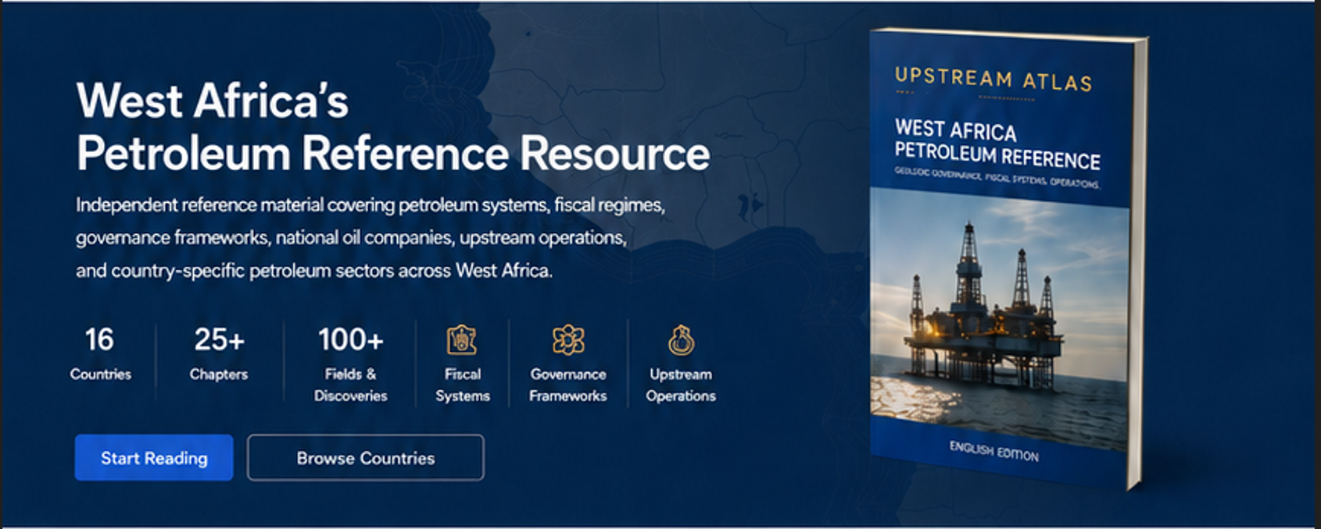
Replace “West Africa's Petroleum Reference Resource” with “West Africa's Independent Petroleum Reference”
Change the statistics to:
- 16
Countries
- 1000+
Fields & Discoveries
- 20+
Sedimentary Basins
- 12
Reference Chapters
- 70+
Years of Exploration
- 50+
Figures & Tables
Start Reading CTA - https://upstreamatlas.com/book/chapters/cover.html
Browse Countries CTA - https://upstreamatlas.com/book/chapters/chapter-03-west-africa-country-analysis.html
Update the book graphic in the Hero Banner to the example below. Add in
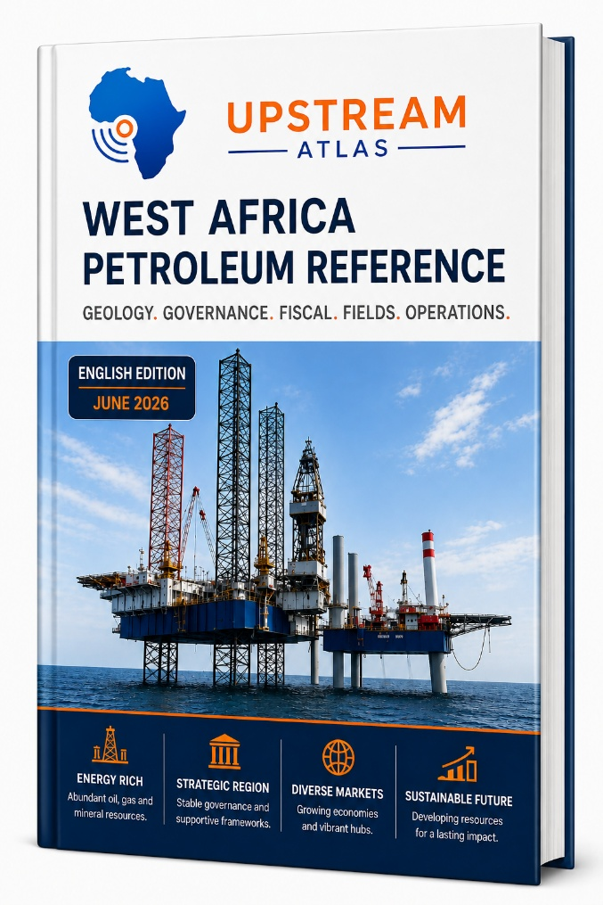

Built for informed decision making section

No change

Coverage Across West Africa section
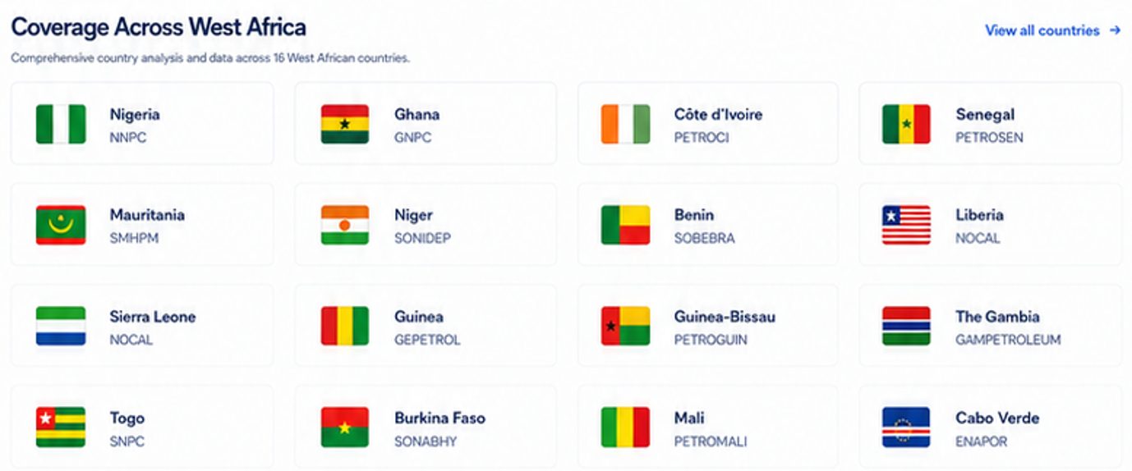
Make each card:
- Country flag
- Country name
- Ministry of Oil & Gas abbreviation | National Oil Company abbreviation
- Hydrocarbons produced (Oil, Gas, Condensate)
- Producing Fields
- Discoveries
- Country Analysis CTA – takes the user to the countries corresponding sub-chapter in chapter 3 of the book
All country cards shall use identical dimensions regardless of content length.
At the very top of every country card
- Green badge if Status is Producing
- Blue badge if Status is Exploration
- Grey badge if Status is No Commercial Production
For example:
- Nigeria
- FMPR | NNPC Ltd
- • Oil • Gas • Condensate
- 140 Producing Fields
- 620 Discoveries
Country Analysis →
Country | Status | Ministry | Abbr. | National Oil Company | Abbr. | Hydrocarbons Produced | Discoveries | Producing Fields
Nigeria | Producing | Federal Ministry of Petroleum Resources | FMPR | Nigerian National Petroleum Company Limited | NNPC Ltd | Oil, Gas, Condensate | 620 | 140
Ghana | Producing | Ministry of Energy and Green Transition | MEGT | Ghana National Petroleum Corporation | GNPC | Oil, Gas, Condensate | 19 | 5
Côte d'Ivoire | Producing | Ministry of Mines, Petroleum and Energy | MMPE | PETROCI Holding | PETROCI | Oil, Gas, Condensate | 35 | 10
Senegal | Producing | Ministry of Energy, Petroleum and Mines | MEPM | PETROSEN | PETROSEN | Oil, Gas, Condensate | 7 | 2
Mauritania | Producing | Ministry of Energy and Petroleum | MEP | Société Mauritanienne des Hydrocarbures | SMH | Gas, Condensate, Oil | 22 | 2
Niger | Producing | Ministry of Petroleum | MP | Société Nigérienne du Pétrole | SONIDEP | Oil | 8 | 2
Benin | Producing | Ministry of Energy, Water and Mines | MEEM | Société Nationale des Hydrocarbures du Bénin | SNH-Bénin | Oil | 5 | 1
Liberia | Exploration | Ministry of Mines and Energy | MME | National Oil Company of Liberia | NOCAL | No Hydrocarbons Produced | 2 | 0
Sierra Leone | Exploration | Petroleum Directorate Sierra Leone | PDSL | Petroleum Directorate Sierra Leone | PDSL | No Hydrocarbons Produced | 2 | 0
Guinea | Exploration | Ministry of Energy, Hydraulics and Hydrocarbons | MEHH | Société Nationale des Pétroles | SONAP | No Hydrocarbons Produced | 1 | 0
Guinea-Bissau | Exploration | Ministry of Natural Resources | MRN | Petroguin | PETROGUIN | No Hydrocarbons Produced | 2 | 0
The Gambia | Exploration | Ministry of Petroleum, Energy and Mines | MPEM | Gambia National Petroleum Company | GAMNPC | No Hydrocarbons Produced | 2 | 0
Togo | No Commercial Production | Ministry of Mines and Energy Resources | MME | None | — | No Hydrocarbons Produced | 0 | 0
Burkina Faso | No Commercial Production | Ministry of Energy, Mines and Quarries | MEMC | None | — | No Hydrocarbons Produced | 0 | 0
Mali | No Commercial Production | Ministry of Mines | MM | Autorité pour la Recherche Pétrolière | AUREP | No Hydrocarbons Produced | 0 | 0
Cabo Verde | No Commercial Production | Ministry of Industry, Trade and Energy | MITE | ENACOL (State Energy Company) | ENACOL | No Hydrocarbons Produced | 0 | 0

Notes
- Nigeria is the largest producer in the region, producing crude oil, associated gas, non-associated gas and condensate. It has by far the largest number of discoveries in West Africa (over 600 named oil and gas discoveries) and around 140 producing fields.
- Ghana produce significant volumes of oil, natural gas and condensate and it’s five producing fields are Jubilee, TEN, Sankofa, Gye Nyame and Ntomme.
- Côte d'Ivoire, produce significant volumes of oil, natural gas and condensate.
- Côte d'Ivoire produce significant volumes of oil, natural gas and condensate and currently has approximately 10 producing fields, including Baleine, Baobab, Espoir and Foxtrot.
- Senegal produces significant volumes of oil, natural gas and condensate and currently has two producing developments: Sangomar (oil) and GTA Phase 1 (gas/condensate).
- Mauritania is currently primarily a natural gas and condensate. It currently produces from Grand Tortue Ahmeyim (shared with Senegal) and Chinguetti as producing developments.
- Niger is currently an oil producer only, with no commercial gas production. It currently produces from the Agadem Rift Basin, with production centred on the Agadem and CNPC-operated developments.
- Benin produced oil historically from the Sèmè Field and has been re-developed recently. Benin has five offshore discoveries, including Sèmè.
- Liberia, Sierra Leone, Guinea, Guinea-Bissau, The Gambia, Togo, Burkina Faso, Mali, and Cabo Verde currently have no commercial hydrocarbon production, although several remain active exploration jurisdictions. These remaining countries have discoveries from exploration drilling.

West African Petroleum Provinces section
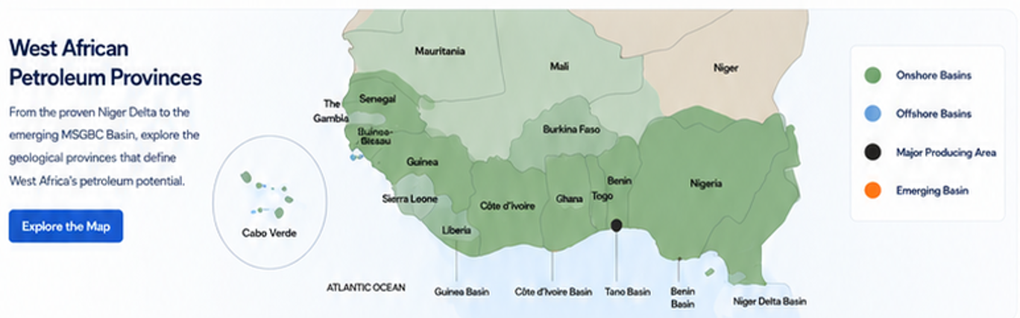
The map should not show information about basins or areas. The map could be a basic political map of West Africa with the countries flags shown inside each country, an example is shown below.
Explore the Map CTA - https://upstreamatlas.com/book/chapters/chapter-02-emerging-petroleum-provinces-in-west-africa.html
If practical within the current development effort, make the map interactive. Otherwise implement the static version first and add interactivity in Version 3 of the website.
Political map
↓
Country flags
↓
Hover popup on laptop / Tap on mobile
↓
Click country
For example, Hover Nigeria and see
Nigeria

Nigerian National Petroleum Company Limited (NNPC)
Federal Ministry of Petroleum Resources (FMPR)

Discoveries
620

Producing Fields
140

Click →

Hover popup on laptop / Tap on mobile for Ghana
Same idea.
This instantly becomes one of the best features of the website.
- Country Name
- Full National Oil Company Name
- Full Ministry of Oil and Gas Name
- Number of Discoveries
- Number of Producing Fields
- CTA to take the user to that countries sub-chapter in Chapter 3
Desktop
4 cards per row
Tablet
2 cards per row
Mobile
1 card per row
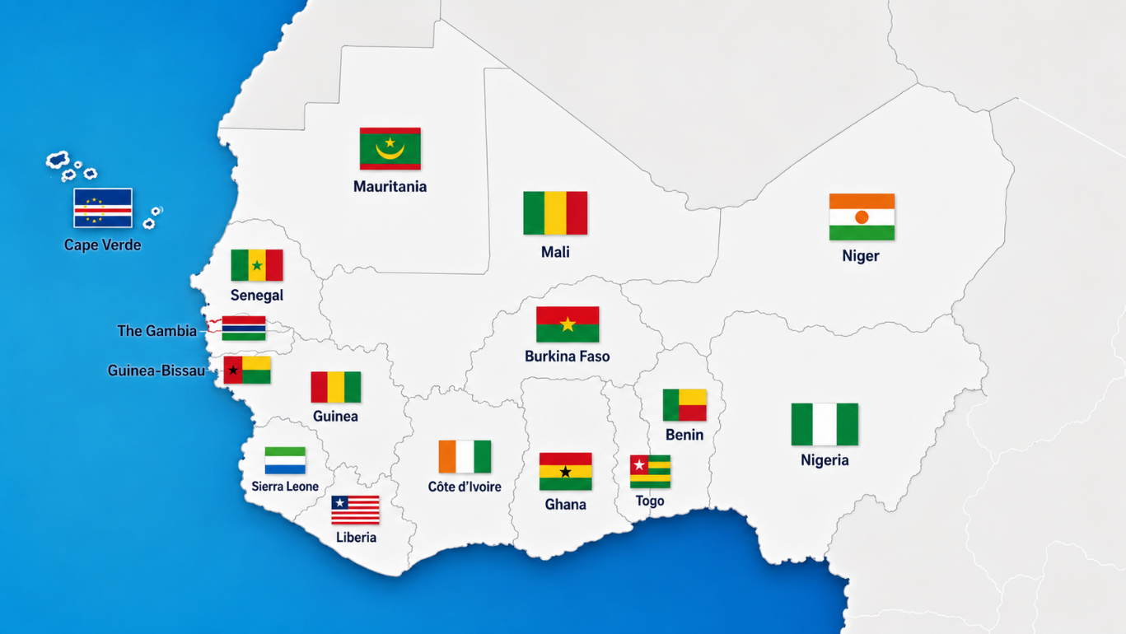

Explore the Reference Library section
Rename this section to be “Browse by Topic”
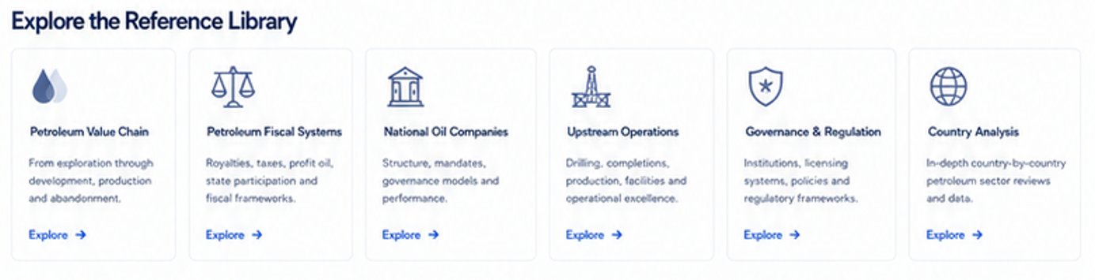
Desktop
6 cards per row
Tablet
3 cards per row
Mobile
1 card per row
Emerging Petroleum Provinces- Explore CTA - https://upstreamatlas.com/book/chapters/chapter-02-emerging-petroleum-provinces-in-west-africa.html
Country Analysis – Explore CTA - https://upstreamatlas.com/book/chapters/chapter-03-west-africa-country-analysis.html
National Oil Companies – Explore CTA – https://upstreamatlas.com/book/chapters/chapter-04-national-oil-companies-in-west-africa.html
Petroleum Value Chain – Explore CTA – https://upstreamatlas.com/book/chapters/chapter-05-hydrocarbon-value-chain.html
Upstream Operations – Explore CTA – https://upstreamatlas.com/book/chapters/chapter-06-upstream-operations-and-government-roles.html
Petroleum Fiscal Systems – Explore CTA – https://upstreamatlas.com/book/chapters/chapter-07-petroleum-fiscal-regimes.html
West Africa’s Fiscal Regimes - Explore CTA - https://upstreamatlas.com/book/chapters/chapter-08-west-african-fiscal-regimes.html
Governance & Regulation – Explore CTA – https://upstreamatlas.com/book/chapters/chapter-09-socio-political-determinants.html
Data Management - Explore CTA - https://upstreamatlas.com/book/chapters/chapter-10-petroleum-data-management-in-west-africa.html
Africa’s Vision – Explore CTA - https://upstreamatlas.com/book/chapters/chapter-12-vision-for-west-africa-2050.html

Key West African Themes section
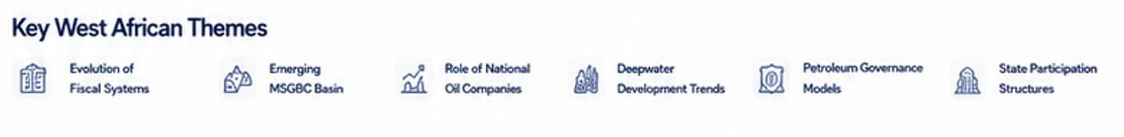
No change.
Search Upstream Atlas section
Add in a new section called “Search Upstream Atlas”
A large search bar. Google-style. This would search the online book only.
Search West African petroleum knowledge...
Countries
National Oil Companies
Ministries
Fields
Discoveries
Basins
Fiscal Systems
Chapters

Authors section
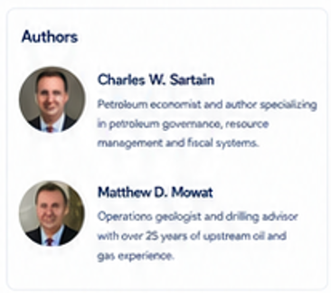
Remove
In its place have “Latest Updates” instead of “Authors”
Latest Updates
✓ English Edition released
✓ Chapter 7 revised
✓ Ghana production data revised
✓ Côte d'Ivoire fiscal terms updated

Current Edition section
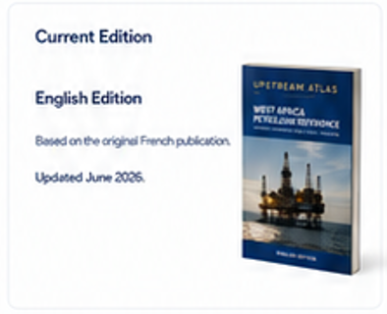
Keep. Can the book use the image below (same book as is used in the Hero section):
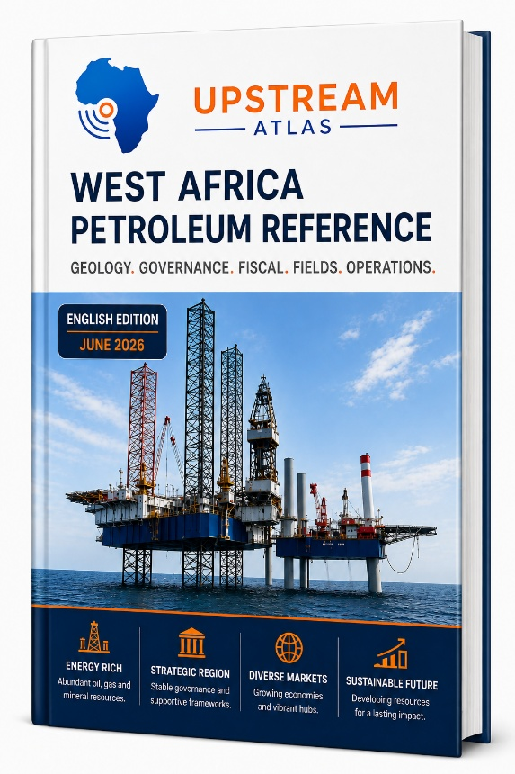

Topics Covered section
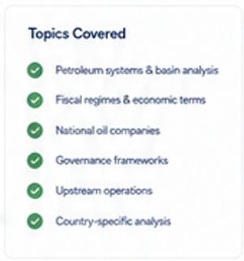
No change.

Future Development section
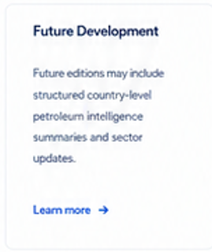
Remove the Learn more CTA.
No quick links section.

Footer section
Add
Coverage
16 Countries
1,000+ Discoveries
140+ Producing Fields
20+ Sedimentary Basins
12 Chapters
National Oil Companies
Government Ministries
Fiscal Systems
Country Analysis

Implementation Priority
Phase 1 (Required for Version 2 Launch)
- Hero section
- Country cards
- Browse by Topic
- Interactive West Africa map
- Search the Book
- Footer updates
Phase 2 (Future Enhancement)
- Interactive map hover popups
- Country statistics auto-generated from database
The overall objective of Version 2 is to establish Upstream Atlas as the leading independent online reference for the West African petroleum sector. The website should prioritise clarity, credibility, fast navigation and long-term scalability over unnecessary visual complexity. All design decisions should reinforce trust, professionalism and ease of access for governments, regulators, national oil companies, operators, investors and researchers.

